Face parts Recognition

## a. For a given image containing human face add salt and pepper noise.

## b. To detect face, nose, mouth, and eye by inserting bounding boxes in the detected region.

## If no region is detected the code may display message like “no eye detected” etc.

# Code:

clc

clear screen

close all

faceDetector = vision.CascadeObjectDetector;

EyeDetector = vision.CascadeObjectDetector('EyePairBig');

NoseDetector = vision.CascadeObjectDetector('Nose');

MouthDetector = vision.CascadeObjectDetector('Mouth');

a = imread('Standing.jpg'); %input image of group of people

c = imnoise(a,'salt & pepper',0.01) %Adding salt and pepper noise

figure, imshow(a)

title('Original image')

figure, imshow(c)

title('Salt and pepper noise image')

Histogram_Equilizer = histeq(c) %Applying Histogram Equilizer for noise cencelation

figure, imshow(Histogram_Equilizer)

title('Histogram Equilizer')

gray = rgb2gray(c) %Coverting rgb to gray

Adapt_hist = adapthisteq(gray); %Apply adaptive histogram

figure, imshow(Adapt_hist);

title('Adapt Histogram Equilizer')

Face_detected = faceDetector(Histogram_Equilizer); %Detecting face from Histeq image and storing it in Face_detected

Eye_detected = EyeDetector(Histogram_Equilizer); %Detecting Eye from Histeq image and storing it in Eye_detected

Nose_detected = NoseDetector(Histogram_Equilizer); %Detecting Nose from Histeq image and storing it in Nose_detected

Mouth_detected = MouthDetector(Histogram_Equilizer); %Detecting mouth from Histeq image and storing it in Mouth_detected

if Face_detected %if face is detected then make rectange accross face

IFaces = insertObjectAnnotation(Histogram_Equilizer,'rectangle',Face_detected,'Face');

else

disp('No face detected')

end

if Eye_detected

IEyes = insertObjectAnnotation(Histogram_Equilizer,'rectangle',Eye_detected,'Eyes');

else

disp('No Eyes detected')

end

if Nose_detected

INose = insertObjectAnnotation(Histogram_Equilizer,'rectangle',Nose_detected,'Nose');

else

disp('No Nose detected')

end

if Mouth_detected

IMouth = insertObjectAnnotation(Histogram_Equilizer,'rectangle',Mouth_detected,'Mouth');

else

disp('No Mouth detected')

end

figure, imshow(IFaces)

title('Detected faces from Histogram_Equilizer');

figure, imshow(IEyes)

title('Detected Eyes from Histogram_Equilizer');

figure, imshow(INose)

title('Detected Nose from Histogram_Equilizer');

figure, imshow(IMouth)

title('Detected Mouth from Histogram_Equilizer');

Face_detected = faceDetector(Adapt_hist); %Detecting face from Adaptive Histogram image and storing it in Face_detected

Eye_detected = EyeDetector(Adapt_hist);

Nose_detected = NoseDetector(Adapt_hist);

Mouth_detected = MouthDetector(Adapt_hist);

if Face_detected

IFaces = insertObjectAnnotation(Adapt_hist,'rectangle',Face_detected,'Face');

else

disp('No face detected')

end

if Eye_detected

IEyes = insertObjectAnnotation(Adapt_hist,'rectangle',Eye_detected,'Eyes');

else

disp('No Eyes detected')

end

if Nose_detected

INose = insertObjectAnnotation(Adapt_hist,'rectangle',Nose_detected,'Nose');

else

disp('No Nose detected')

end

if Mouth_detected

IMouth = insertObjectAnnotation(Adapt_hist,'rectangle',Mouth_detected,'Mouth');

else

disp('No Mouth detected')

end

figure, imshow(IFaces)

title('Detected faces from Adapt hist');

figure, imshow(IEyes)

title('Detected Eyes from Adapt hist');

figure, imshow(INose)

title('Detected Nose from Adapt hist');

figure, imshow(IMouth)

title('Detected Mouth from Adapt hist');

# Output

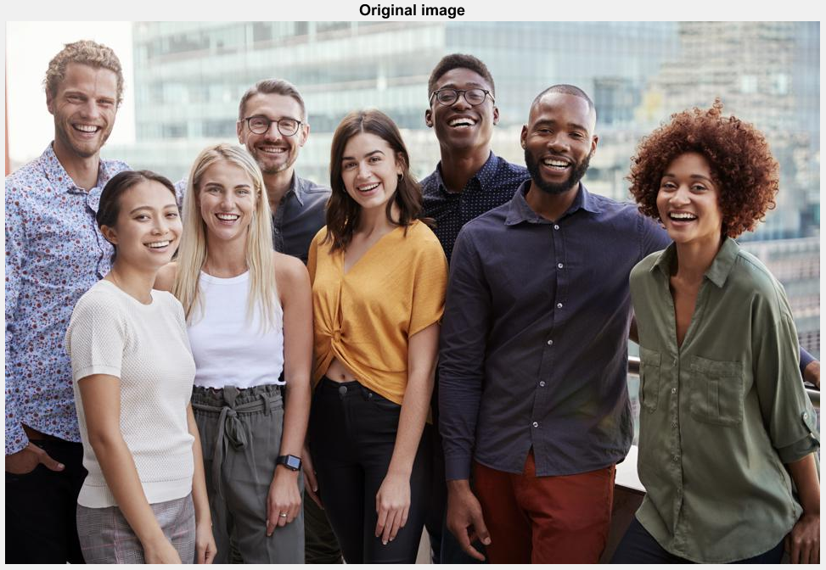 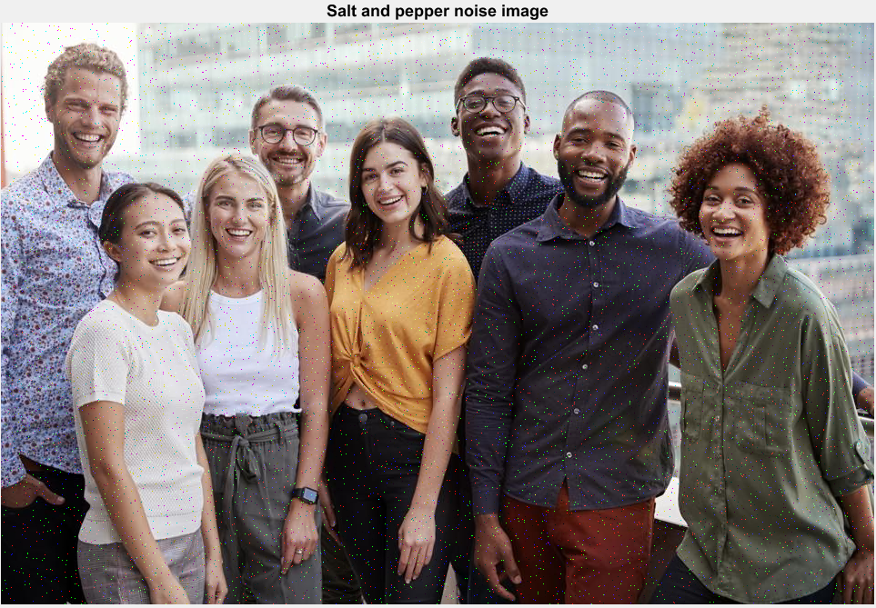

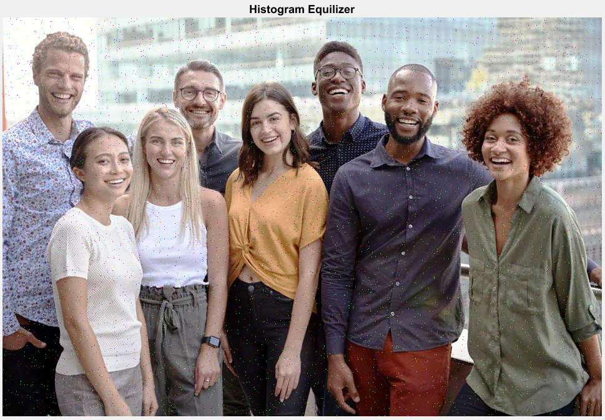 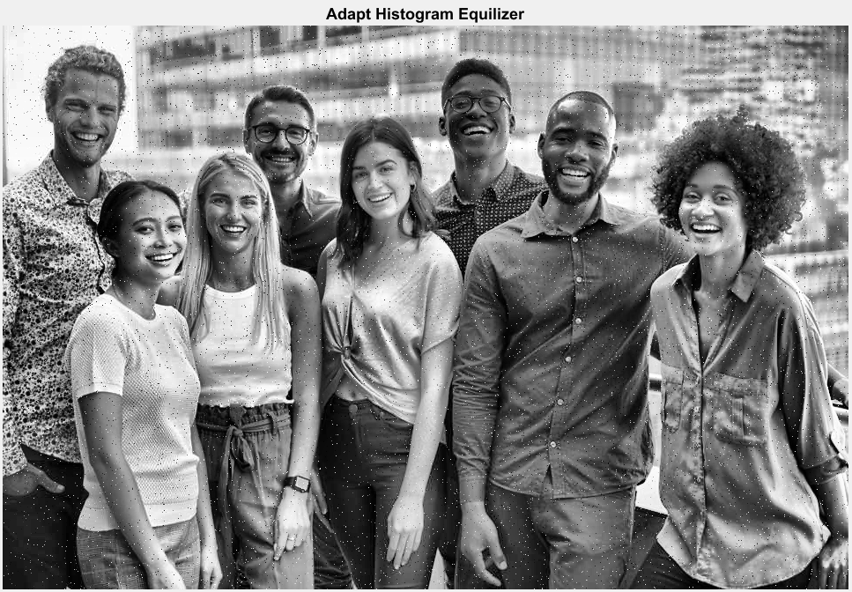

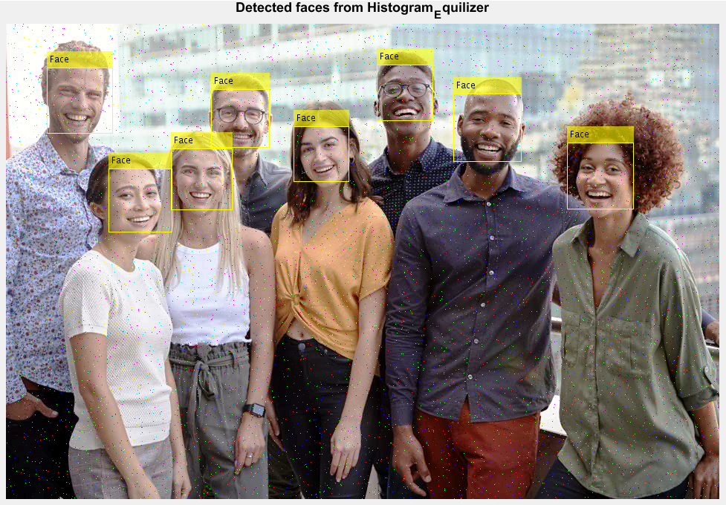 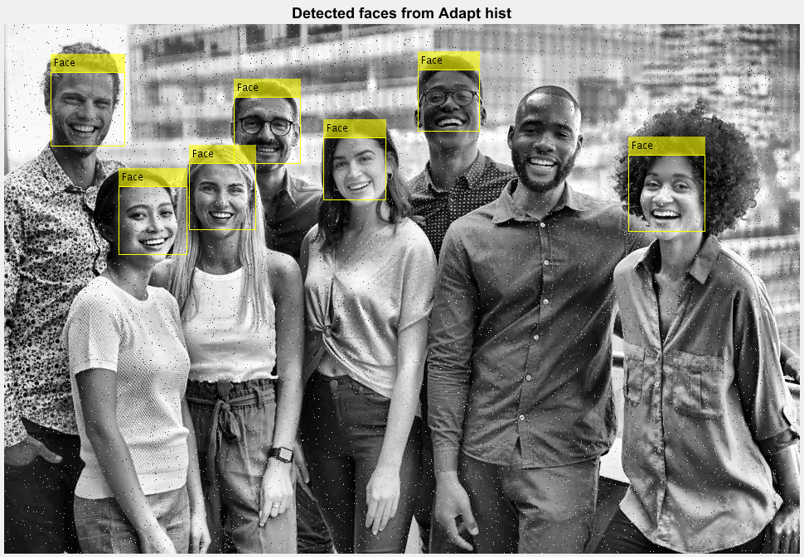

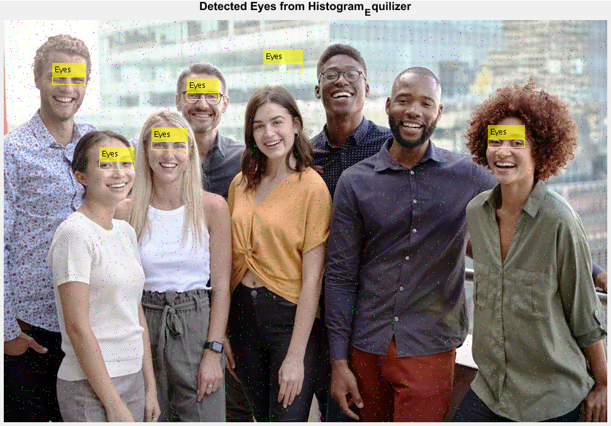 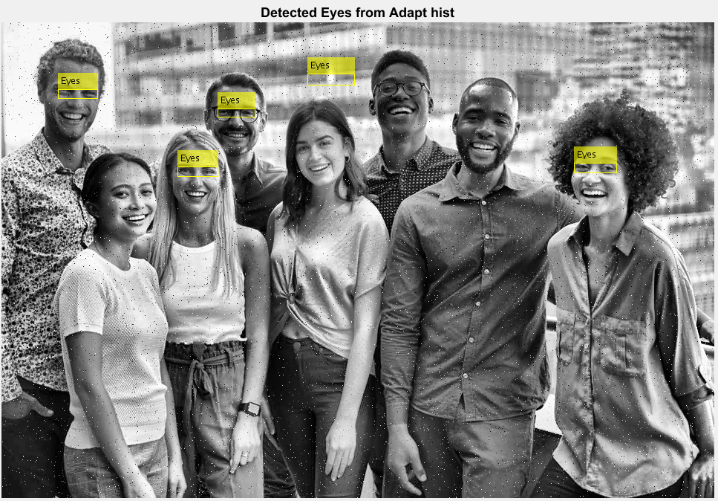

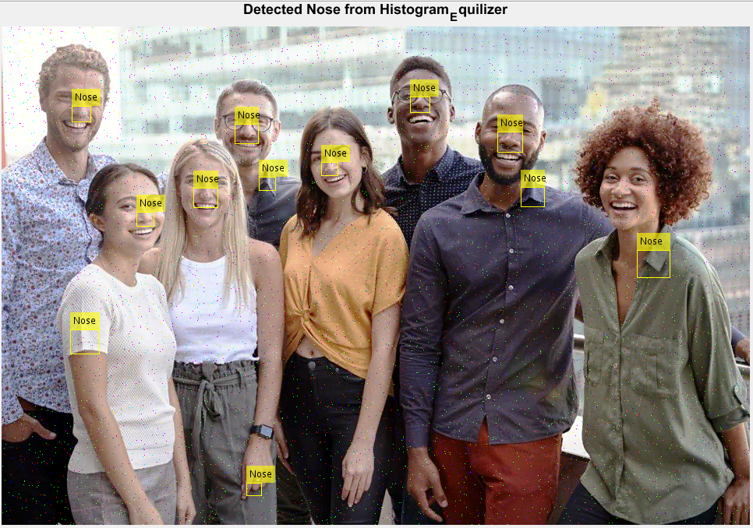 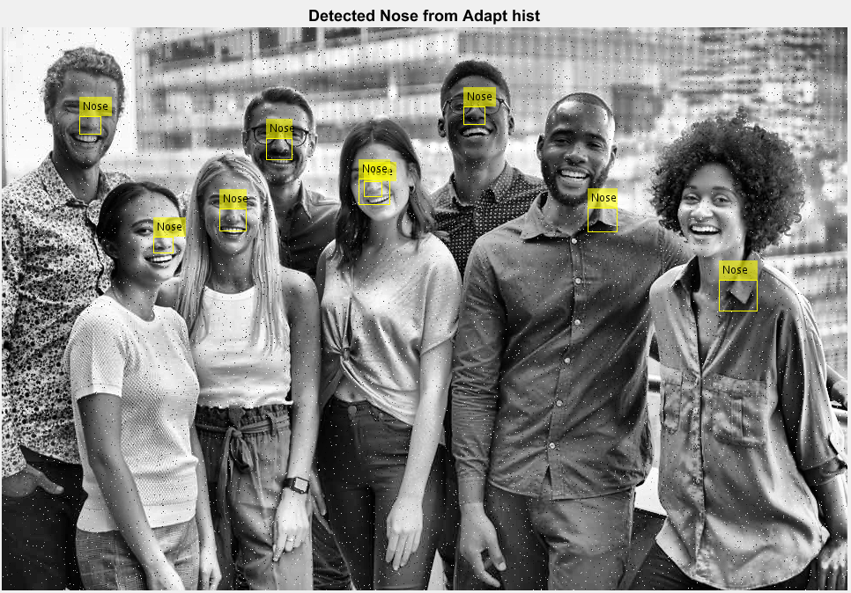

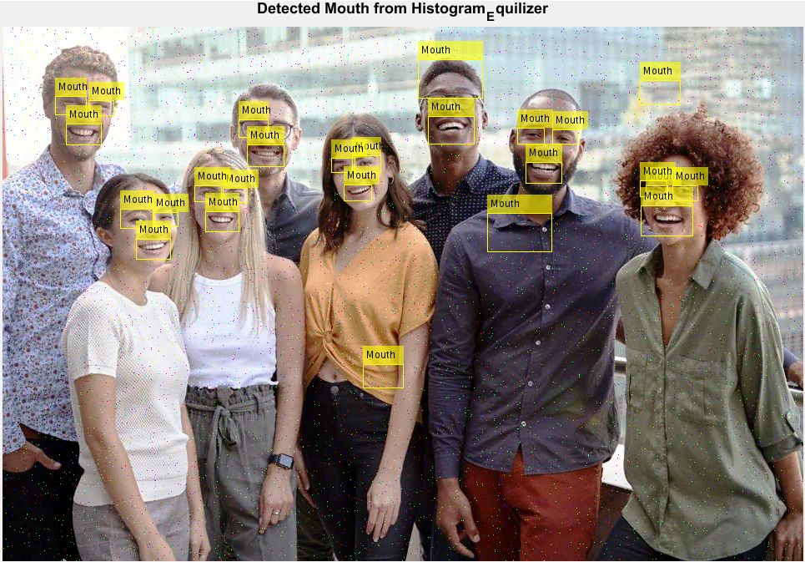 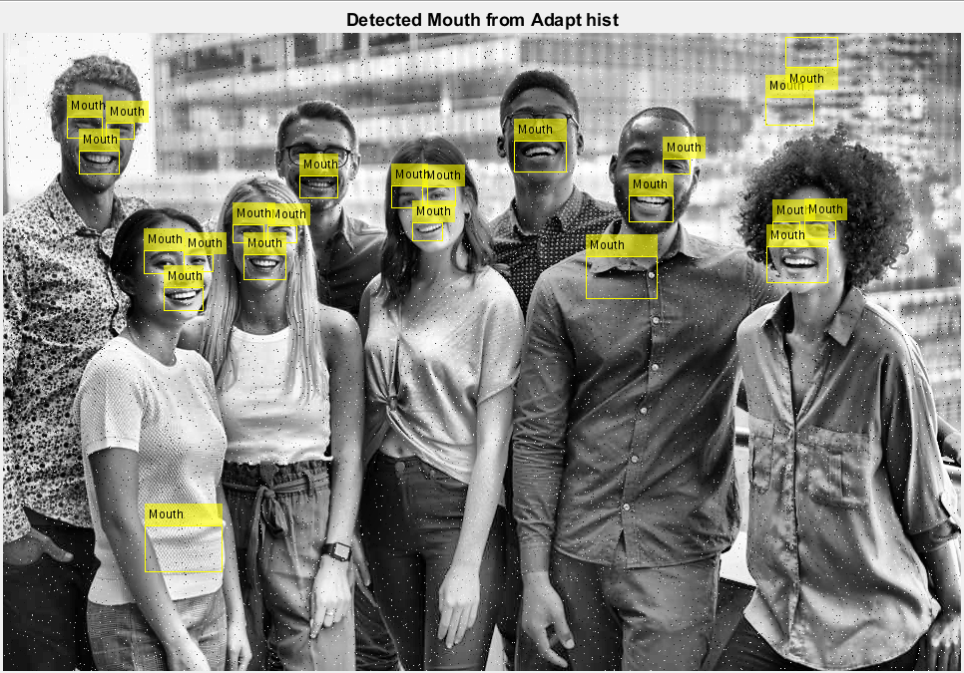

## c. Apply image enhancement technique (histogram equalization and adaptive histogram equalization) and comment on effect of image enhancement techniques in detection of face, nose, mouth, and eye with respect to any one recent research paper.

# Solution:

As we saw from the results, for detection of objects **adaptive histogram**

**Equalization** is better filter for noise cancelation than **histogram equalization.**

# Explanation

Histogram Equalization is a computer image processing technique used to improve contrast in images. It accomplishes this by effectively spreading out the most frequent intensity values, i.e., stretching out the intensity range of the image. This method usually increases the global contrast of images when its usable data is represented by close contrast values. This allows for areas of lower local contrast to gain a higher contrast. A color histogram of an image represents the number of pixels in each type of color component. Histogram equalization cannot be applied separately to the Red, Green and Blue components of the image as it leads to dramatic changes in the image’s color balance. However, if the image is first converted to another color space, like HSL/HSV color space, then the algorithm can be applied to the luminance or value channel without resulting in changes to the hue and saturation of the image.

Adaptive Histogram Equalization differs from ordinary histogram equalization in the respect that the adaptive method computes several histograms, each corresponding to a distinct section of the image, and uses them to redistribute the lightness values of the image. It is therefore suitable for improving the local contrast and enhancing the definitions of edges in each region of an image.

## Reference:

Yu Wang; Qian Chen; Baeomin Zhang, “Image enhancement based on equal area dualistic sub-image histogram equalization method”. IEEE. Feb. 1999 [https://ieeexplore.ieee.org/abstract/document/754419](https://ieeexplore.ieee.org/abstract/document/754419%20)

Stephen M.Pizer, E. Philip, John D.Austin, “Adaptive histogram equalization and its variations”. Science Direct. September 1987 < <https://www.sciencedirect.com/science/article/abs/pii/S0734189X8780186X>>

Shreenidhi Sudhakar, “Histogram Equalization”. Towards data science. July 10, 2017 < <https://towardsdatascience.com/histogram-equalization-5d1013626e64#:~:text=Adaptive%20Histogram%20Equalization%20differs%20from,lightness%20values%20of%20the%20image>.>